3.62: a) Using the same algebra as in Problem 3.58(a), 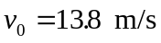.
b) Again, the algebra is the same as that used in Problem 3.58; 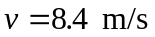, at an angle of 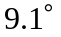, this time above the horizontal.
c) The graph of 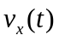 is a horizontal line.
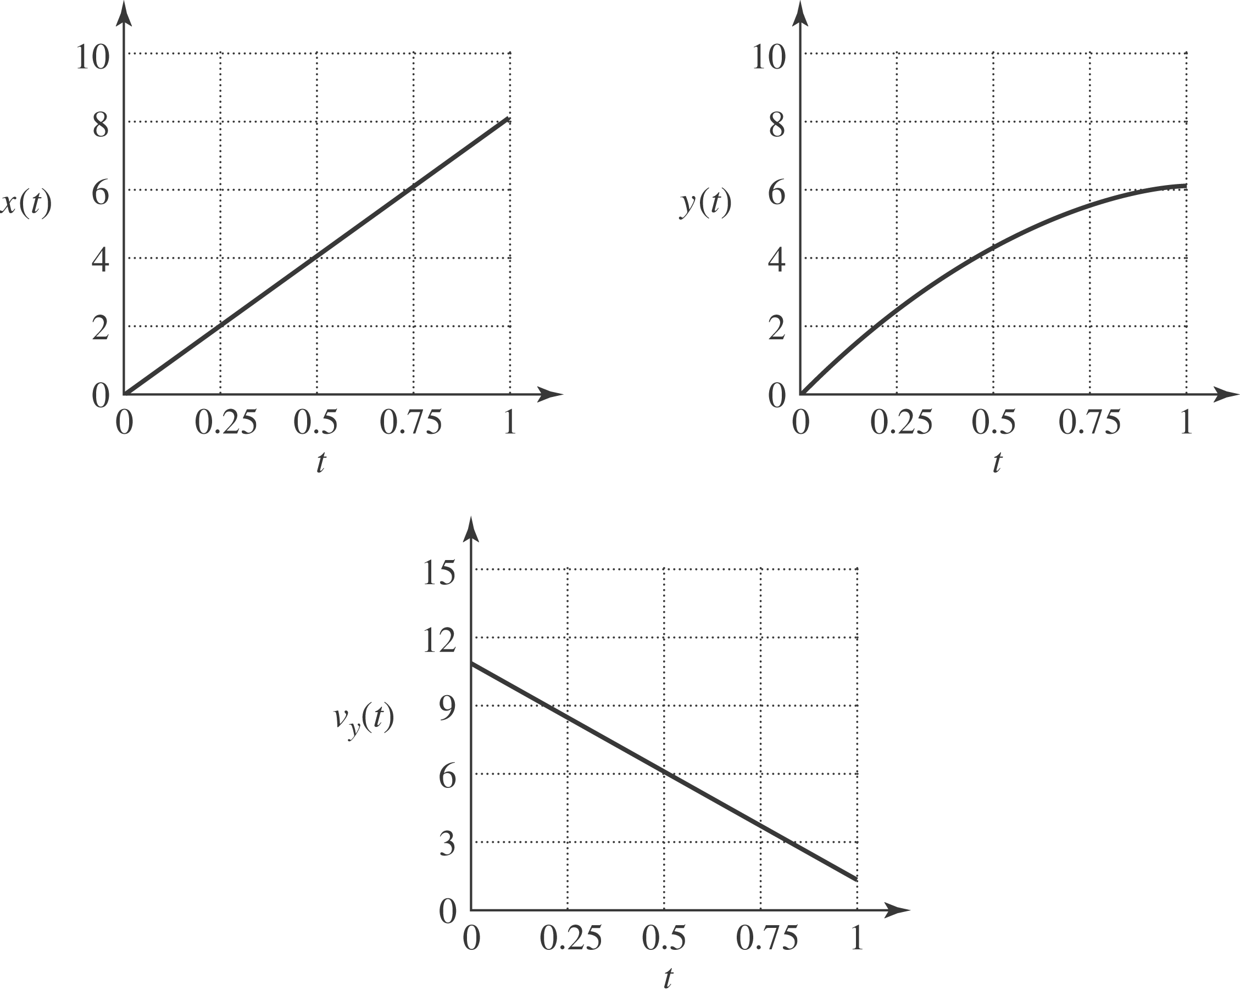
A graph of 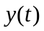 vs.  shows the trajectory of Mary Belle as viewed from the side:
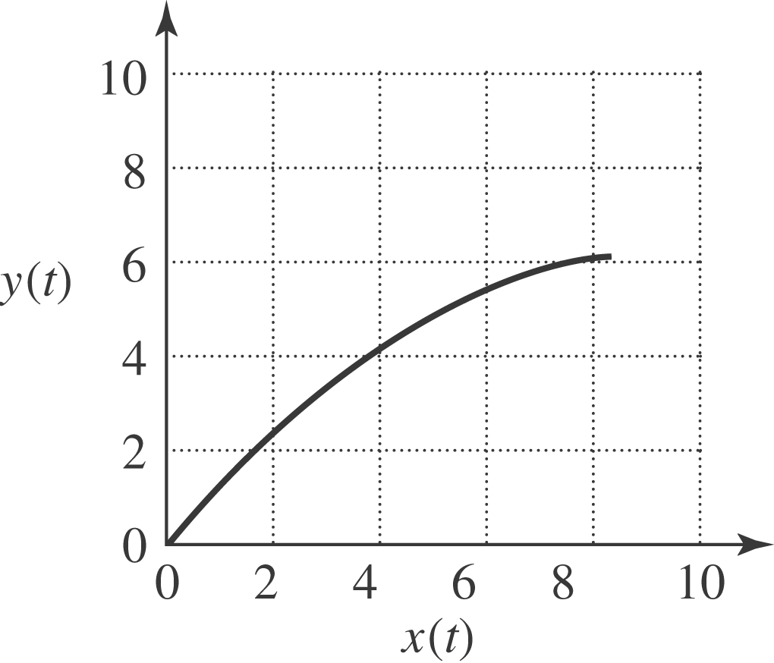

d) In this situation it’s convenient to use Eq. (3.27), which becomes 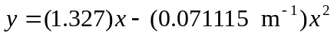. Use of the quadratic formula gives 

